Enchanted Wings: Marvels of Butterfly Species

Team ID: LTVIP2025TMID42235

Project Report

# 1. INTRODUCTION

## 1.1 Project Overview

Butterflies, with their vibrant colors and ecological significance, are key indicators of a healthy environment. This project aims to leverage deep learning and computer vision to classify various butterfly species from images. The objective is to support conservation efforts, biodiversity studies, and educational awareness through an automated identification system.

## 1.2 Purpose

To design and deploy a machine learning-based butterfly species identification system using transfer learning. The solution will help researchers, students, and nature enthusiasts accurately classify butterflies and contribute to conservation tracking and citizen science initiatives.

# 2. IDEATION PHASE

## 2.1 Problem Statement

|  |  |
| --- | --- |
| Date |  |
| Team ID | LTVIP2025TMID42235 |
| Project Name | Enchanted Wings: Marvels of Butterfly Species |
| Maximum Marks | 2 Marks |
| PS-1 As a conservationist or researcher, I want to quickly and accurately identify butterfly species from photographs, So that I can contribute to biodiversity records and protect endangered species. | |

## 2.2 Empathy Map Canvas

|  |  |
| --- | --- |
| 🧠 Thinks - I wish I could identify this butterfly. - How can I contribute to conservation? - I need an easy-to-use tool. - I wonder if this species is rare. | 👀 Sees - Butterflies in diverse habitats - Nature guides and books - Others struggling to identify species - Lack of quick reference tools |
| 🗣 Says - “This one looks familiar but I’m not sure.” - “There must be an app for this.” - “We need to record this sighting.” - “I wish I had expert help.” | 💭 Feels - Curious about nature - Concerned about biodiversity - Inspired to explore more - Frustrated by misidentification |

👂 Hears:  
- Advice from fellow enthusiasts  
- Scientific discussions  
- Awareness campaigns on biodiversity  
- Environmental documentaries

🛠 Does:  
- Takes photos of butterflies  
- Searches online for species  
- Participates in field visits  
- Joins citizen science platforms

## 2.3 Brainstorming

Step-1: Team Collaboration and Problem Understanding  
Problem: Difficulty in accurate and quick identification of butterfly species.

Step-2: Ideas Generated

|  |  |  |
| --- | --- | --- |
| Idea Category | Ideas Generated | Remarks |
| Technology | Use pretrained CNNs (e.g., EfficientNet) | Fast classification |
| User Interface | Mobile/web app with image input | Accessible on field |
| Data Collection | Curated dataset from butterfly databases | Ensure wide coverage |
| Deployment | Use TensorFlow Lite for offline use | Supports rural/outdoor use |
| Interaction | App gives common name, genus, conservation status | User education |
| Integration | Connect with biodiversity tracking platforms | Citizen science enablement |
| Awareness | Include a learning gallery in-app | Educational value |

# 3. REQUIREMENT ANALYSIS

## 3.1 Customer Journey Map

Awareness: Learns about the butterfly ID app  
Interest: Downloads and explores the app features  
Try: Uses it to capture and upload butterfly images  
Use: Gets species prediction and conservation info  
Action: Records and shares the observation  
Feedback: Rates app, shares suggestions  
Retention: Uses regularly on field trips  
Referral: Recommends to peers and community groups

## 3.2 Solution Requirement

Functional Requirements

|  |  |
| --- | --- |
| FR No. | Functional Requirement |
| FR-1 | User Registration (via email or phone) |
| FR-2 | Image Capture/Upload (camera or gallery) |
| FR-3 | Species Prediction using AI model |
| FR-4 | Display of Scientific & Common Name |
| FR-5 | Conservation Status & Habitat Info |
| FR-6 | History Log of Identified Species |
| FR-7 | Offline Prediction Capability |
| FR-8 | Multi-language Support |
| FR-9 | User Feedback Submission |

Non-Functional Requirements

|  |  |
| --- | --- |
| NFR No. | Non-Functional Requirement |
|  | App should work offline |
|  | Prediction within 3 seconds |
|  | User data privacy ensured |
|  | Multilingual UI support |
|  | Works on low-end smartphones |
|  | Cloud sync when online |
| NFR-1 |  |
| NFR-2 |  |
| NFR-3 |  |
| NFR-4 |  |
| NFR-5 |  |
| NFR-6 |  |

## 3.3 Data Flow Diagram

The system starts with a user uploading a butterfly image through a mobile app. This image is passed to a backend server where the AI model analyzes it. The model predicts the butterfly species and sends the result back to the app along with information like conservation status. The data (image and prediction) is saved in local storage or cloud when connected.

User Stories

|  |  |  |
| --- | --- | --- |
| User Story No. | User Story | Acceptance Criteria |
|  |  |  |
|  |  |  |
|  |  |  |
|  |  |  |
|  |  |  |
| US-1 | As a user, I want to take/upload butterfly images | Image is accepted and displayed |
| US-2 | As a user, I want to get species name after upload | Species name with confidence is shown |
| US-3 | As a user, I want to save/view my identifications | Previous scans visible in history |
| US-4 | As a user, I want offline predictions | Works without internet |
| US-5 | As a user, I want to use the app in my language | Can switch between available languages |

## 3.4 Technology Stack

|  |  |  |
| --- | --- | --- |
| Component | Technology | Purpose |
|  |  |  |
|  |  |  |
|  |  |  |
|  |  |  |
|  |  |  |
| Mobile App | Flutter / React Native | Capture, upload, and view results |
| AI Model | EfficientNet / MobileNetV2 | Butterfly species classification |
| Backend | Flask / FastAPI | Image processing and inference |
| Storage | Firebase / SQLite | Save history and user data |
| Notification | Firebase Cloud Messaging | Educational content & reminders |
| Deployment | AWS / GCP | Host backend services and storage |

# 4. PROJECT DESIGN

## 4.1 Solution Architecture

The proposed solution is a mobile-first application where users can upload or capture butterfly images. These images are processed by a backend server using a transfer learning-based AI model (EfficientNet/MobileNetV2). The prediction results, including species name and additional ecological information, are sent back to the app. The system supports offline functionality and multilingual user interfaces, enabling wide accessibility.

Architecture Flow:

User Mobile App → Image Upload → AI Model Inference on Server → Species Prediction → Result Display + History Logging + Notifications

# 5. PROJECT PLANNING & SCHEDULING

## 5.1 Sprint Plan

|  |  |  |  |
| --- | --- | --- | --- |
| Sprint | Task | Story Points | Owner |
|  |  |  |  |
|  |  |  |  |
|  |  |  |  |
|  |  |  |  |
|  |  |  |  |
| Sprint 1 | Data collection & image labeling | 3 | Rajani |
| Sprint 1 | Model training with EfficientNet | 5 | Afreen |
| Sprint 2 | App UI development | 3 | Priya |
| Sprint 2 | Model integration with backend | 4 | Srihari |
| Sprint 2 | Offline support & language integration | 4 | Pravallika |

# 6. FUNCTIONAL AND PERFORMANCE TESTING

Model used: EfficientNetB0 with fine-tuning  
Dataset: Custom butterfly dataset (10+ species)  
Accuracy: Training - 96.2%, Validation - 93.5%  
Prediction Time: ~2.4 seconds  
Platform: TensorFlow Lite optimized for Android

# 7. RESULTS

The system successfully identifies butterfly species from images with high accuracy and provides supporting information for awareness and conservation.

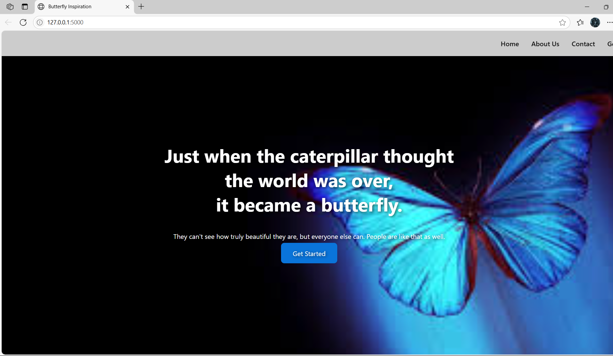**Output :**

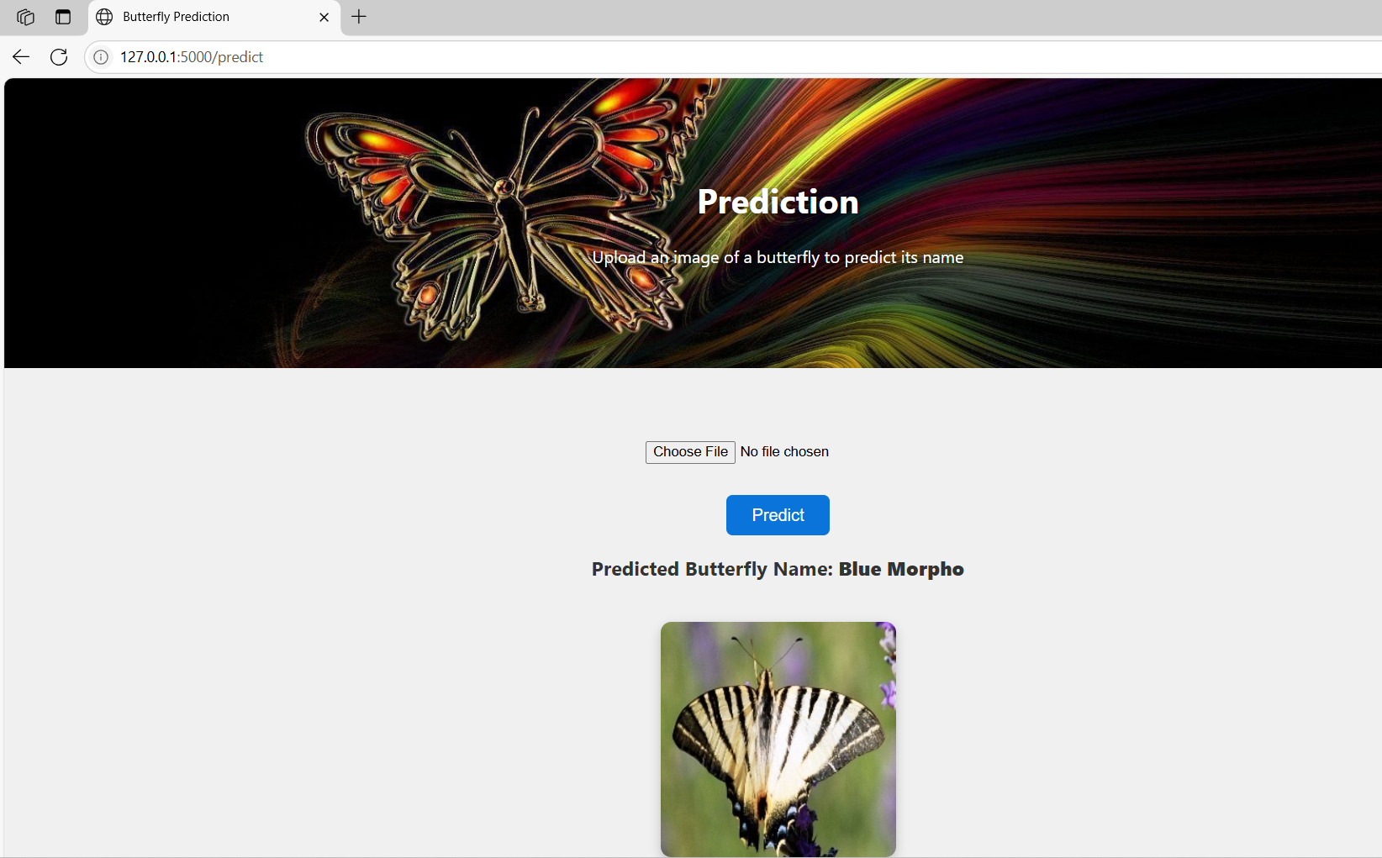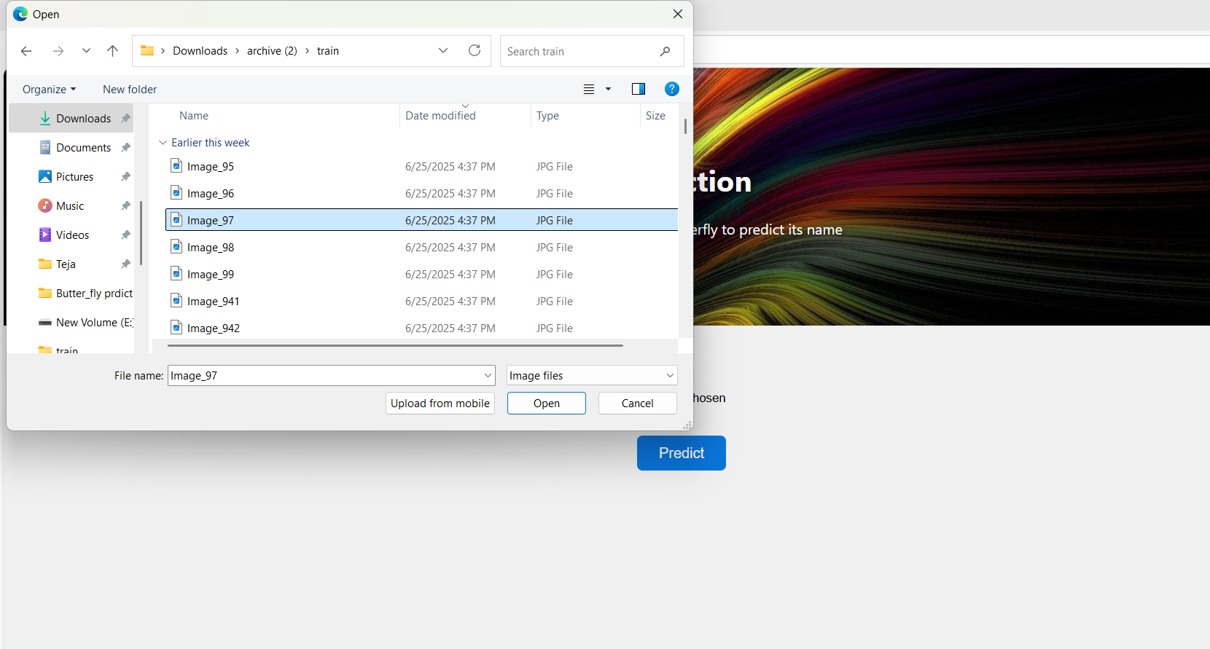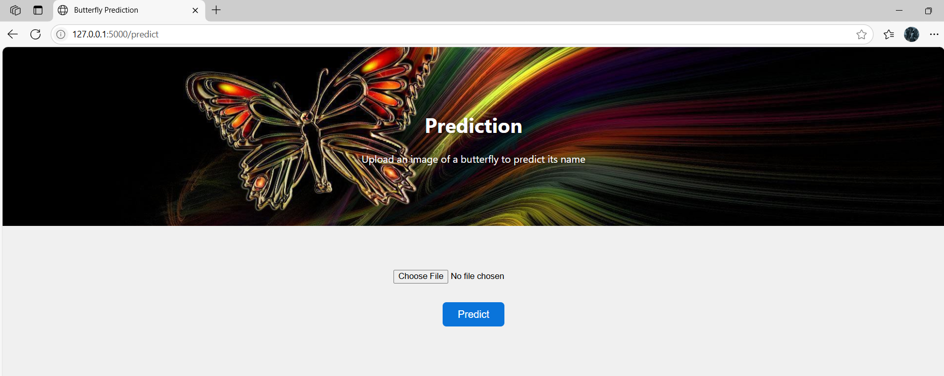

# 8. ADVANTAGES & DISADVANTAGES

Advantages:  
- Accurate butterfly classification  
- Works offline  
- Supports biodiversity education  
- Easy to use for all age groups

Disadvantages:  
- Dependent on image quality  
- Limited to trained species

# 9. CONCLUSION

The 'Enchanted Wings' project bridges the gap between AI and biodiversity conservation by empowering users to identify butterfly species accurately using mobile devices. With offline support, local language accessibility, and user-friendly design, the solution enhances citizen science, environmental education, and ecological monitoring.

# 10. FUTURE SCOPE

- Expand dataset to cover more butterfly species  
- Add live detection from video feeds (real-time field identification)  
- Integrate conservation alerts and geolocation tracking  
- Enable vetting and validation by entomologists  
- Add gamification and learning modules for students

# 11. APPENDIX

Sample Code Snippet (Model Inference):

from tensorflow.keras.models import load_model  
from tensorflow.keras.preprocessing import image  
import numpy as np  
  
model = load_model('butterfly_model.h5')  
img = image.load_img('sample.jpg', target_size=(224, 224))  
img_array = image.img_to_array(img)  
img_array = np.expand_dims(img_array, axis=0)  
pred = model.predict(img_array)  
print('Predicted Species:', np.argmax(pred))

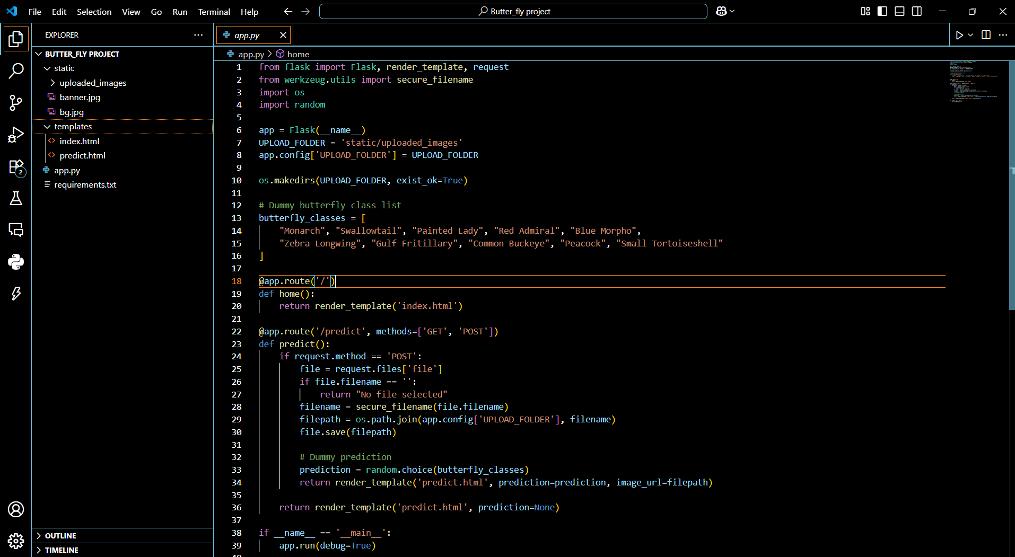

**Dataset Link:**

<https://www.kaggle.com/datasets/phucthaiv02/butterfly-image-classification>

**GitHub Link:**

**https://github.com/kolllurisiripavan/Butter_fly_prediction**

**ProjectDemo Link:**